

**KATHFORD INTERNATIONAL COLLEGE OF**

**ENGINEERING AND MANAGEMENT**

Balkumari, Lalitpur

A

Minor Project

On

**“Facial Expression Based Music Recommendation System using CNN”**

**Project Members**

Aavash Baral (KIC077BCT001)

Gaurav Pyakurel (KIC077BCT017)

Adish Bhattarai (KIC077BCT006)

Dikshita Poudel (KIC077BCT016)

**DEPARTMENT OF COMPUTER AND ELECTRONICS AND COMMUNICATION ENGINEERING**

**LALITPUR, NEPAL**

**MARCH, 2024**



**KATHFORD INTERNATIONAL COLLEGE OF**

**ENGINEERING AND MANAGEMENT**

Balkumari, Lalitpur

A

Minor Project

On

**“Facial Expression Based Music Recommendation System using CNN”**

[Subject Code: CT654]

**Project Members**

Aavash Baral (KIC077BCT001)

Gaurav Pyakurel (KIC077BCT017)

Adish Bhattarai (KIC077BCT006)

Dikshita Poudel (KIC077BCT016)

A PROJECT WAS SUBMITTED TO THE DEPARTMENT OF COMPUTER AND

ELECTRONICS, COMMUNICATION & INFORMATION ENGINEERING IN

PARTIAL FULLFILLMENT OF THE REQUIREMENT FOR THE BACHELOR’S

DEGREE IN COMPUTER ENGINEERING

**DEPARTMENT OF COMPUTER AND ELECTRONICS AND COMMUNICATION ENGINEERING**

**LALITPUR, NEPAL**

**MARCH, 2024**

**KATHFORD INTERNATIONAL COLLEGE OF ENGINEERING AND MANAGEMENT**

# PAGE OF APPROVAL

**BALKUMARI, LALITPUR**

**DEPARTMENT OF COMPUTER AND ELECTRONICS, COMMUNICATION & INFORMATION ENGINEERING**

The undersigned certify that they have read, and recommended to this department for acceptance, a project report entitled “**Facial Expression Based Music Recommendation System using CNN”**, submitted by **Aavash Baral, Gaurav Pyakurel, Adish Bhattarai and Dikshita Poudel** in partial fulfilment of the requirements for the Bachelor’s degree in Computer Engineering.

------------------------------------------------------------

Coordinator,

Jalauddin Mansur

**DATE OF APPROVAL**: 9th March 2024

# COPYRIGHT

The authors have agreed that the Library, Department of Computer and Electronics, Communication and Information Engineering, Kathford International College may make this report freely available for inspection. Moreover, the author has agreed that permission for extensive copying of this project report for scholarly purpose may be granted by the supervisors who supervised the project work recorded herein or, in their absence, by the Head of the Department wherein the project report was done. It is understood that the recognition will be given to the author of this report and to the Department of Computer and Electronics, Communication and Information Engineering, Kathford International College in any use of the material of this project report. Copying or publication or the other use of this report for financial gain without approval of to the Department of Computer and Electronics, Communication and Information Engineering, Kathford International College and author’s written permission is prohibited.

Request for permission to copy or to make any other use of the material in this report in whole or in part should be addressed to:

Chaitya Shova Shakya

Department of Computer and Electronics, Communication and Information Engineering, Kathford International College of Engineering and Management

Lalitpur, Nepal

# ACKNOWLEDGEMENT

We extend our sincere appreciation to the Department of Computer and Electronics, Communication & Information Engineering, IOE, Kathford International College Of Engineering and Management, for granting us the opportunity to undertake a Minor Project as part of our curriculum. We are deeply grateful to our project coordinator, **Er. Jalauddin Mansur**, for his unwavering support and guidance throughout the project duration.

Additionally, we wish to express our gratitude to **Er. Prabin Kumar Jha**, Head of the Computer and Electronics, Communication & Information Department, for his support. Our heartfelt thanks also go to all our instructors for their insightful suggestions and motivational lectures, which greatly contributed to the completion of this project.

Finally, we would like to acknowledge our colleagues for their valuable feedback and suggestions during the project.

# ABSTRACT

This research project delves into the complex relationship between music and human emotions, introducing an innovative Facial Expression Music-Based Recommendation System powered by Convolutional Neural Networks (CNN). The system aims to analyze facial expressions to accurately discern users' emotional states, subsequently suggesting music tracks that resonate with and potentially amplify or modulate their emotional experiences. Leveraging a comprehensive dataset of 35,887 grayscale facial images (48x48 pixels) from the FER2013 dataset, the system adopts a data-driven approach, dividing the dataset into a 9:1 ratio for training and testing the CNN model. The system's architecture combines the OpenCV2 Cascade Classifier for frontal face detection with the CNN for emotional state recognition, achieving a notable testing accuracy of 81.71%. To enhance user interaction, the system integrates a GUI using the pygame library, enabling users to capture their facial expressions for emotion recognition and receive tailored music recommendations accordingly. This Facial Expression Music-Based Recommendation System exhibits promising applications across domains such as music therapy, personalized entertainment, and emotional well-being, showcasing the potential of deep learning and computer vision techniques in understanding and enhancing human experiences.

Top of Form

Top of Form

**Keywords**

Emotion Detection, Convolutional Neural Network, Pygame, OpenCV, FER2013

TABLE OF CONTENTS

PAGE OF APPROVAL ii

COPYRIGHT iii

ACKNOWLEDGEMENT iv

ABSTRACT v

LIST OF FIGURES viii

LIST OF TABLES ix

LIST OF ABBREVIATIONS x

1. INTRODUCTION 1

1.1 Background 1

1.2 Problem Statement 2

1.3 Objectives 2

1.4 Scopes 3

2. LITERATURE REVIEW 4

3. REQUIREMENT ANALYSIS 6

3.1 Feasibility Study 6

3.1.1 Technical Feasibility 6

3.1.2 Economic Feasibility 6

3.1.3 Operational Feasibility 7

3.1.4 Schedule Feasibility 7

3.1.5 Legal and Ethical Feasibility 7

3.2 Software Requirement Specification 8

3.2.1 Data Requirements: 8

3.2.2 Functional Requirements: 8

3.2.3 Non-Functional Requirements: 9

3.2.4 Security Requirements: 9

4. PROJECT METHODOLOGY 10

4.1 Development Model 10

4.2 Block Diagram 11

4.2.1 Webcam 11

4.2.2 Frontal Face Detection using Haar Cascade Classifier: 11

4.2.3 Pre-processing: 12

4.2.4 Emotion Recognition using CNN: 12

4.2.5 FER2013 Dataset: 12

4.2.6 Music Recommender: 13

4.3 CNN Architecture 14

4.3.1 Input Layer: 14

4.3.2 Convolutional Layers: 14

4.3.3 MaxPooling Layers: 14

4.3.4 Fully Connected Layers: 15

4.3.5 Output Layer: 15

5. SYSTEM DESIGN 16

5.1 Activity Diagram 16

5.2 Use Case Diagram 17

5.3 Data Flow Diagram 18

5.4 Sequence Diagram 19

6. RESULTS AND DISCUSSION 20

6.2 Perfomance Metrics Overview 20

6.3 Visualization of Training vs Validation Accuracy 21

6.3 Visualization of Training vs Validation Loss 22

6.4 Confusion Matrix 23

6.5 ROC-AUC Curve 24

7. CONCLUSION 25

8. LIMITATIONS AND FUTURE WORK 26

8.1 Limitations 26

8.2 Future Works 27

REFERENCES 28

APPENDICES 29

# LIST OF FIGURES

Figure 1: Iterative and Incremental Development Model 10

Figure 2: Block Diagram of Proposed System 11

Figure 3: CNN Architecture 14

Figure 4: Activity Diagram 16

Figure 5: Use Case Diagram 17

Figure 6: Level 0 DFD 18

Figure 7: Level 1 DFD 18

Figure 8: Sequence Diagram 19

Figure 9: Classification Report 20

Figure 10: Training vs Validation Accuracy 21

Figure 11: Training vs Validation Loss 22

Figure 12: Confusion Matrix 23

Figure 13: ROC-AUC Curve 24

Figure 14: FER2013 Dataset 29

Figure 15: Sample Images from FER2013 Dataset 30

Figure 17: Emotion Classification: True vs Predicted Values 31

Figure 18: Neutral emotion detected in GUI 32

# LIST OF TABLES

Table 1: Scope Table 3

# LIST OF ABBREVIATIONS

AI Artificial Intelligence

CNN Convolutional Neural Network

FER2013 Facial Expression Recognition 2013

ML Machine Learning

UI User Interface

# INTRODUCTION

## Background

Music is a powerful medium that is intricately interconnected with human emotions, capable of uplifting one's mood. Evolutionary speculations have tended to focus on single-source causes such as music as an indicator of biological ﬁtness, music as a means for social and emotional communication, music as social glue, music as a way of facilitating caretaker mobility, music as a means of tempering anxiety about mortality, music as escapism or transcendental meaning, music as a source of pleasure, and music as a means for passing time [1]. The rise of various digital musical platforms has led to an increased demand for personalized music systems. As a result, consumers now expect music services that cater to their individual preferences, offering tailored playlists, recommendations, and a seamless user experience.

In recent years, advances in artificial intelligence and deep learning have opened new possibilities for improving music recommendation systems. Musical preferences have been demonstrated to be highly related to personality traits and moods.Facial expressions are a powerful indicator of human emotions and can provide valuable cues for understanding how individuals feel at any given moment. Employing Convolutional Neural Networks (CNN), a class of deep learning algorithms well-suited for image recognition tasks, allows the detection and analysis of facial expressions in real-time.

Top of Form

The FER2013 dataset, a widely used benchmark for facial emotion recognition, will serve as a valuable resource for training CNN model. This dataset contains a diverse range of facial expressions labeled with emotions such as happiness, anger, sadness and neutrality. By utilizing this dataset, an emotion detection model can be built that can accurately identify users' emotional states through their facial expressions.

## Problem Statement

The current landscape of music selection systems lacks a comprehensive and efficient approach to cater to users' real-time emotional states, resulting in suboptimal music recommendations. Existing methods rely on manual input, wearable devices, or audio-based classification, which may not accurately capture the user's emotional context at a given moment. This limitation leads to a less engaging and personalized music experience for users.

Traditional music selection techniques based on manual sorting or audio features fail to consider the dynamic nature of human emotions. Wearable devices, though capable of monitoring certain physiological indicators, may not capture facial expressions, which are powerful indicators of emotions. Additionally, audio-based classification might not accurately discern the user's emotional state in real-time.

## Objectives

The main objective of this project is to develop an automatic music selection system that utilizes facial emotion recognition through Convolutional Neural Networks (CNN) to enhance the user's music experience based on their real-time emotional states. The project aims to achieve the following specific objectives:

* To develop a emotion detection model using CNN
* To recommend musics based on emotion

## Scopes

This project is centered around Desktop Application Development with a core focus on enhancing Human-Computer Interaction (HCI). The project encompasses several key applications:

Table 1: Scope Table

|  |  |
| --- | --- |
| **Scope** | **Description** |
| **Personalized music recommendations** | Real-time analysis of facial expressions tailors music suggestions, creating a deeply immersive and emotionally resonant listening experience. |
| **Accessibility for non-verbal users** | Enabling non-verbal individuals, it opens a new avenue for emotional expression through facial input, fostering music discovery aligned with their moods. |
| **Mental health applications** | Integrating facial expression monitoring with music preferences for potential early detection of mood disorders and personalized music therapy recommendations. |

* **Top of Form**

# LITERATURE REVIEW

The convergence of artificial intelligence (AI) and music recommendation systems has ignited a revolution in personalized music experiences. Researchers are delving into the potential of facial expression analysis to propel music recommendations to a new level of emotional resonance and relevance.

The intricate connection between facial expressions and emotional responses to music forms the bedrock of this exploration. Studies by Yang et al. [2] reveal a robust correlation, demonstrating the feasibility of leveraging facial cues to infer emotional preferences. This paves the way for personalized recommendations that cater to the user's current emotional state.

Recent advan`cements in the field are exemplified by Bin Li and Dimas Lima's work [3], achieving an impressive 95.39% accuracy using ResNet-50 with the Lu 2016 dataset. However, acknowledging the limitations is crucial. The study's relatively small dataset of 700 images raises concerns about generalizability and robustness. The model's performance might be susceptible to the limited diversity and quantity of images employed.

Sadhvika, Abigna, and Reddy (2020) [4] propose a novel approach that leverages facial emotion recognition for music recommendations. Their system automatically selects songs based on the user's emotions, identified through facial expressions. By incorporating the Viola-Jones algorithm and Support Vector Machines, the system offers improved emotion classification. Additionally, the Fisherface algorithm strengthens the system's ability to recognize a broader spectrum of emotions, leading to a more intuitive and personalized music experience.

The research by Athavle et al. (2021) [5] explored facial emotion recognition for personalized music suggestions, achieving an accuracy of about 95.14% with a CNN architecture and the FER2013 dataset. Another study by Ahmed Hamdy et al. focused on observing human emotions through facial expressions, claiming an accuracy of more than 90% with a basic 4-emotion model (happy, sad, angry, and neutral). [6] A. Mahadik et al.'s study introduced a mood-based music player using MobileNet, achieving around 75% accuracy in real-time mood detection, trained on a combined dataset from FER 2013. [7]

In summary, the current literature highlights the potential of AI-driven music recommendation systems incorporating facial expression analysis. The mentioned studies form the basis for our project, which aims to improve user experience by offering personalized music suggestions aligned with users' emotional states.

# REQUIREMENT ANALYSIS

## 3.1 Feasibility Study

### 3.1.1 Technical Feasibility

* **Availability of Technology and Data**

The technology required for the emotion-based music recommendation app, including ML libraries like TensorFlow, Keras, and PyTorch, is widely available and accessible. Pygame, as a Python library, facilitates the creation of a user-friendly graphical user interface, enabling users to interact seamlessly with the application. The FER2013 dataset, containing labeled facial expression images, is publicly available and serves as the primary dataset for training the emotion recognition model.

* **Expertise and Skill Set**

Adequate expertise in deep learning, computer vision, and software development is essential. The project team possesses the required skills or can acquire them through training and collaboration.

### 3.1.2 Economic Feasibility

* **Development Costs**

To minimize development costs, we will leverage open-source tools, libraries, and frameworks. Our primary investment will be the time and effort contributed by team members.

* **Hardware Infrastructure**

To access advanced hardware resources without significant expenses, we will utilize Google Colab, a free cloud-based platform that offers GPU support for machine learning tasks.

### 3.1.3 Operational Feasibility

* **Integration and Compatibility**

Our emotion-based music recommendation system's success depends on seamlessly integrating the CNN-based emotion detection model and Pygame user interfaces. The CNN model will operate in the backend, enabling real-time facial emotion analysis, while the Pygame-based interface will offer a user-friendly and visually appealing experience. Compatibility across devices and platforms, including laptops, desktops, and mobile devices, will be ensured.

* **User Acceptance**

User feedback and testing will assess the system's usability and whether users find the automatic music selection based on facial emotions to be beneficial and enjoyable.

### 3.1.4 Schedule Feasibility

* **Realistic Project Timeline**

We will set a realistic and achievable project timeline, breaking down the development process into manageable phases. Each phase will have specific milestones and deadlines to monitor progress effectively.

* **Task Prioritization**

Tasks will be prioritized based on their dependencies and criticality, ensuring that essential components are addressed first. This approach will enable the completion of foundational elements before moving to subsequent phases.

### 3.1.5 Legal and Ethical Feasibility

Compliance with data protection regulations and ensuring user data privacy is crucial. Proper consent from users for data collection and usage must be obtained.

## 3.2 Software Requirement Specification

### 3.2.1 Data Requirements:

* **Type:** Images of human faces expressing various emotions.
* **Source:** FER2013 dataset (preferred) or any other dataset containing labeled facial expressions (neutral, happy, sad, angry, surprised, fearful, disgust).
* **Format:** Grayscale images of fixed size (e.g., 48x48 pixels).
* **Volume:** 35,900 images for training and sufficient images for validation and testing.
* **Additional Data:** Music metadata including: genre, tempo, mood, lyrics (optional).

### 3.2.2 Functional Requirements:

* **Facial Expression Recognition:**
  + Capture real-time webcam footage or analyze pre-recorded images.
  + Employ a pre-trained CNN model (e.g., using FER2013) to predict the user's dominant facial expression from the visual input.
* **Music Recommendation:**
  + Based on the recognized emotion, recommend a song or playlist that matches the user's current mood.
  + Utilize a pre-defined mapping between emotions and musical characteristics (e.g., happy - upbeat tempo, sad - slow tempo, etc.).
* **User Interface:**
  + Provide a user-friendly interface for accessing the system.
  + Display captured webcam footage or uploaded images.
  + Show recognized emotions with confidence scores.
  + Display recommended songs with relevant information (title, artist, genre, etc.).

### 3.2.3 Non-Functional Requirements:

* **Performance:**
  + Real-time facial expression recognition with minimal latency.
* **Reliability:**
  + Accurate facial expression recognition even with slight variations in lighting and facial features.
  + Recommend relevant songs consistently based on recognized emotions.
* **Security:**
  + User privacy should be protected.
  + Webcam footage and personal data should be securely stored and transmitted.

### 3.2.4 Security Requirements:

* Implement secure protocols for data transmission and storage.
* Follow ethical guidelines for data collection and usage

# PROJECT METHODOLOGY

## Development Model

The Iterative and Incremental Development Model is suitable approach for the proposed system, as it perfectly fits our dynamic team and flexible project requirements. In this model, we can collectively contribute to different aspects of the system, allowing us to learn and experiment collaboratively. We can divide the project into smaller, manageable increments, with each increment adding new functionalities and improvements to the system.

Since we all have diverse skill sets and interests, the Iterative and Incremental approach enables us to work on different components based on our strengths. For instance, some team members can focus on facial expression analysis and emotion detection, while others can work on the UI part. As we progress through iterations, we can integrate our individual efforts to create a coherent and functional system.

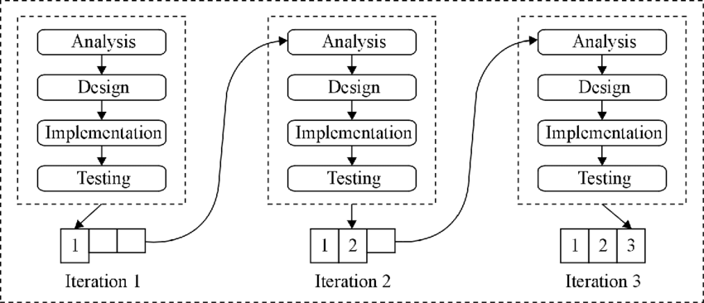

Figure 1: Iterative and Incremental Development Model

## Block Diagram

Figure 2: Block Diagram of Proposed System

### 4.2.1 Webcam

The system continuously captures live video frames (webcam feed) as its primary image source.

### 4.2.2 Frontal Face Detection using Haar Cascade Classifier:

OpenCV2 Haarcascade algorithms then efficiently detect and isolate the frontal face region within each frame, ensuring emotion recognition focuses on relevant features.

### 4.2.3 Pre-processing:

Pre-processing of the dataset includes following steps:

* **Grayscale Conversion**: Converting the images to grayscale can reduce complexity and allow the model to focus on the essential facial features.
* **Data Augmentation**: This technique can be employed to artificially expand the dataset by creating variations of existing images (e.g., rotations, flipping). This can help the model generalize better to unseen data.
* **Normalization**: Normalization in image processing involves scaling pixel values to a standardized range, like converting from 0 to 255 to a range of 0 to 1. This process enhances consistency and aids in efficient processing of images.

### 4.2.4 Emotion Recognition using CNN:

The emotion recognition CNN model comprises convolutional layers with batch normalization, ReLU activation, and dropout for regularization. Max pooling layers aid in feature map downsampling, capturing crucial spatial information. The architecture progressively extracts hierarchical features, enabling discernment of intricate patterns linked to emotional states. The output layer with softmax activation classifies input images into seven distinct emotion categories.

Top of Form

### 4.2.5 FER2013 Dataset:

The fer2013 dataset stands as a prevalent resource in computer vision and emotion recognition, offering a collection of facial expressions. With 35,887 grayscale images of human faces, it categorizes emotions into seven distinct categories: anger, disgust, fear, happiness, sadness, surprise, and neutral. The dataset is divided into training and testing/validation sets, with 90% allocated for training purposes and the remaining 10% for testing/validation.

### 4.2.6 Music Recommender:

A pre-defined mapping database links each predicted emotion to its corresponding musical characteristics (tempo, genre, lyrics, mood keywords). Based on this mapping, the system recommends sutiable songs from a pre-classified music library.

## CNN Architecture

Figure 3: CNN Architecture

### Input Layer:

The input layer accepts grayscale images of size 48x48 pixels with a single channel. This is specified by the input shape (48, 48, 1).

### Convolutional Layers:

The convolutional layers are responsible for extracting relevant features from input images, capturing visual cues linked to emotions. Initially, smaller filter sizes detect low-level features like edges and textures, while deeper layers with larger filters capture complex patterns aiding emotion recognition. Various padding techniques handle spatial dimensions, while batch normalization stabilizes training and potentially enhances performance. Through multiple convolutional layers, the model extracts rich features encompassing facial expressions for emotion classification.

### MaxPooling Layers:

The MaxPooling layers are used to downsample the feature maps by taking the maximum value in each 2x2 window. This operation reduces the spatial dimensions of the feature maps, which helps to reduce computational complexity and control overfitting.

### Fully Connected Layers:

The fully connected layers are responsible for combining the extracted features and making the final classification decision.

* Dense Layer: This is a fully connected layer with 250 neurons and ReLU activation function. It processes and combines the features extracted by the convolutional layers.

### Output Layer:

The output layer is a fully connected layer with 7 neurons, each representing a class in the classification task. The softmax activation function is applied to this layer to compute the probabilities of each class, allowing the model to make predictions.

# SYSTEM DESIGN

In our project,we've taken a function-focused approach.This helped us organize tasks clearly and made our findings easier to understand and use.

## Activity Diagram

Figure 4: Activity Diagram

## Use Case Diagram

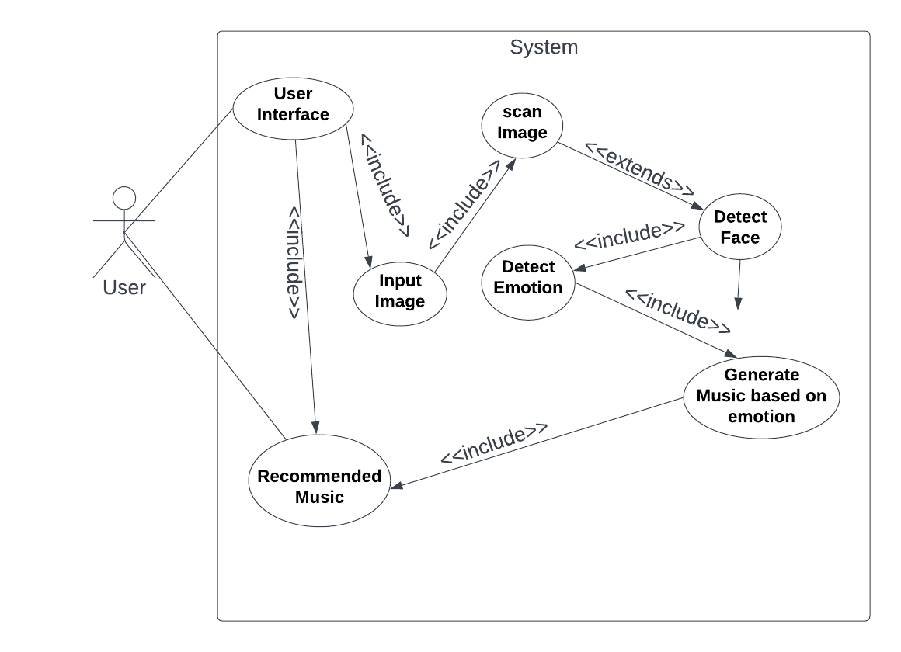

## 

Figure 5: Use Case Diagram

## Data Flow Diagram

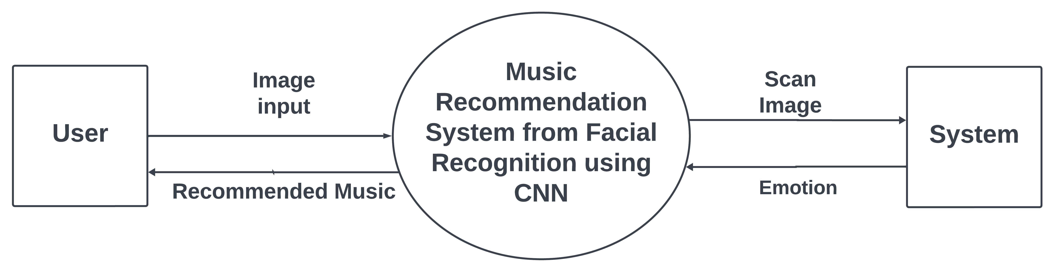

## 

### 

Figure 6: Level 0 DFD

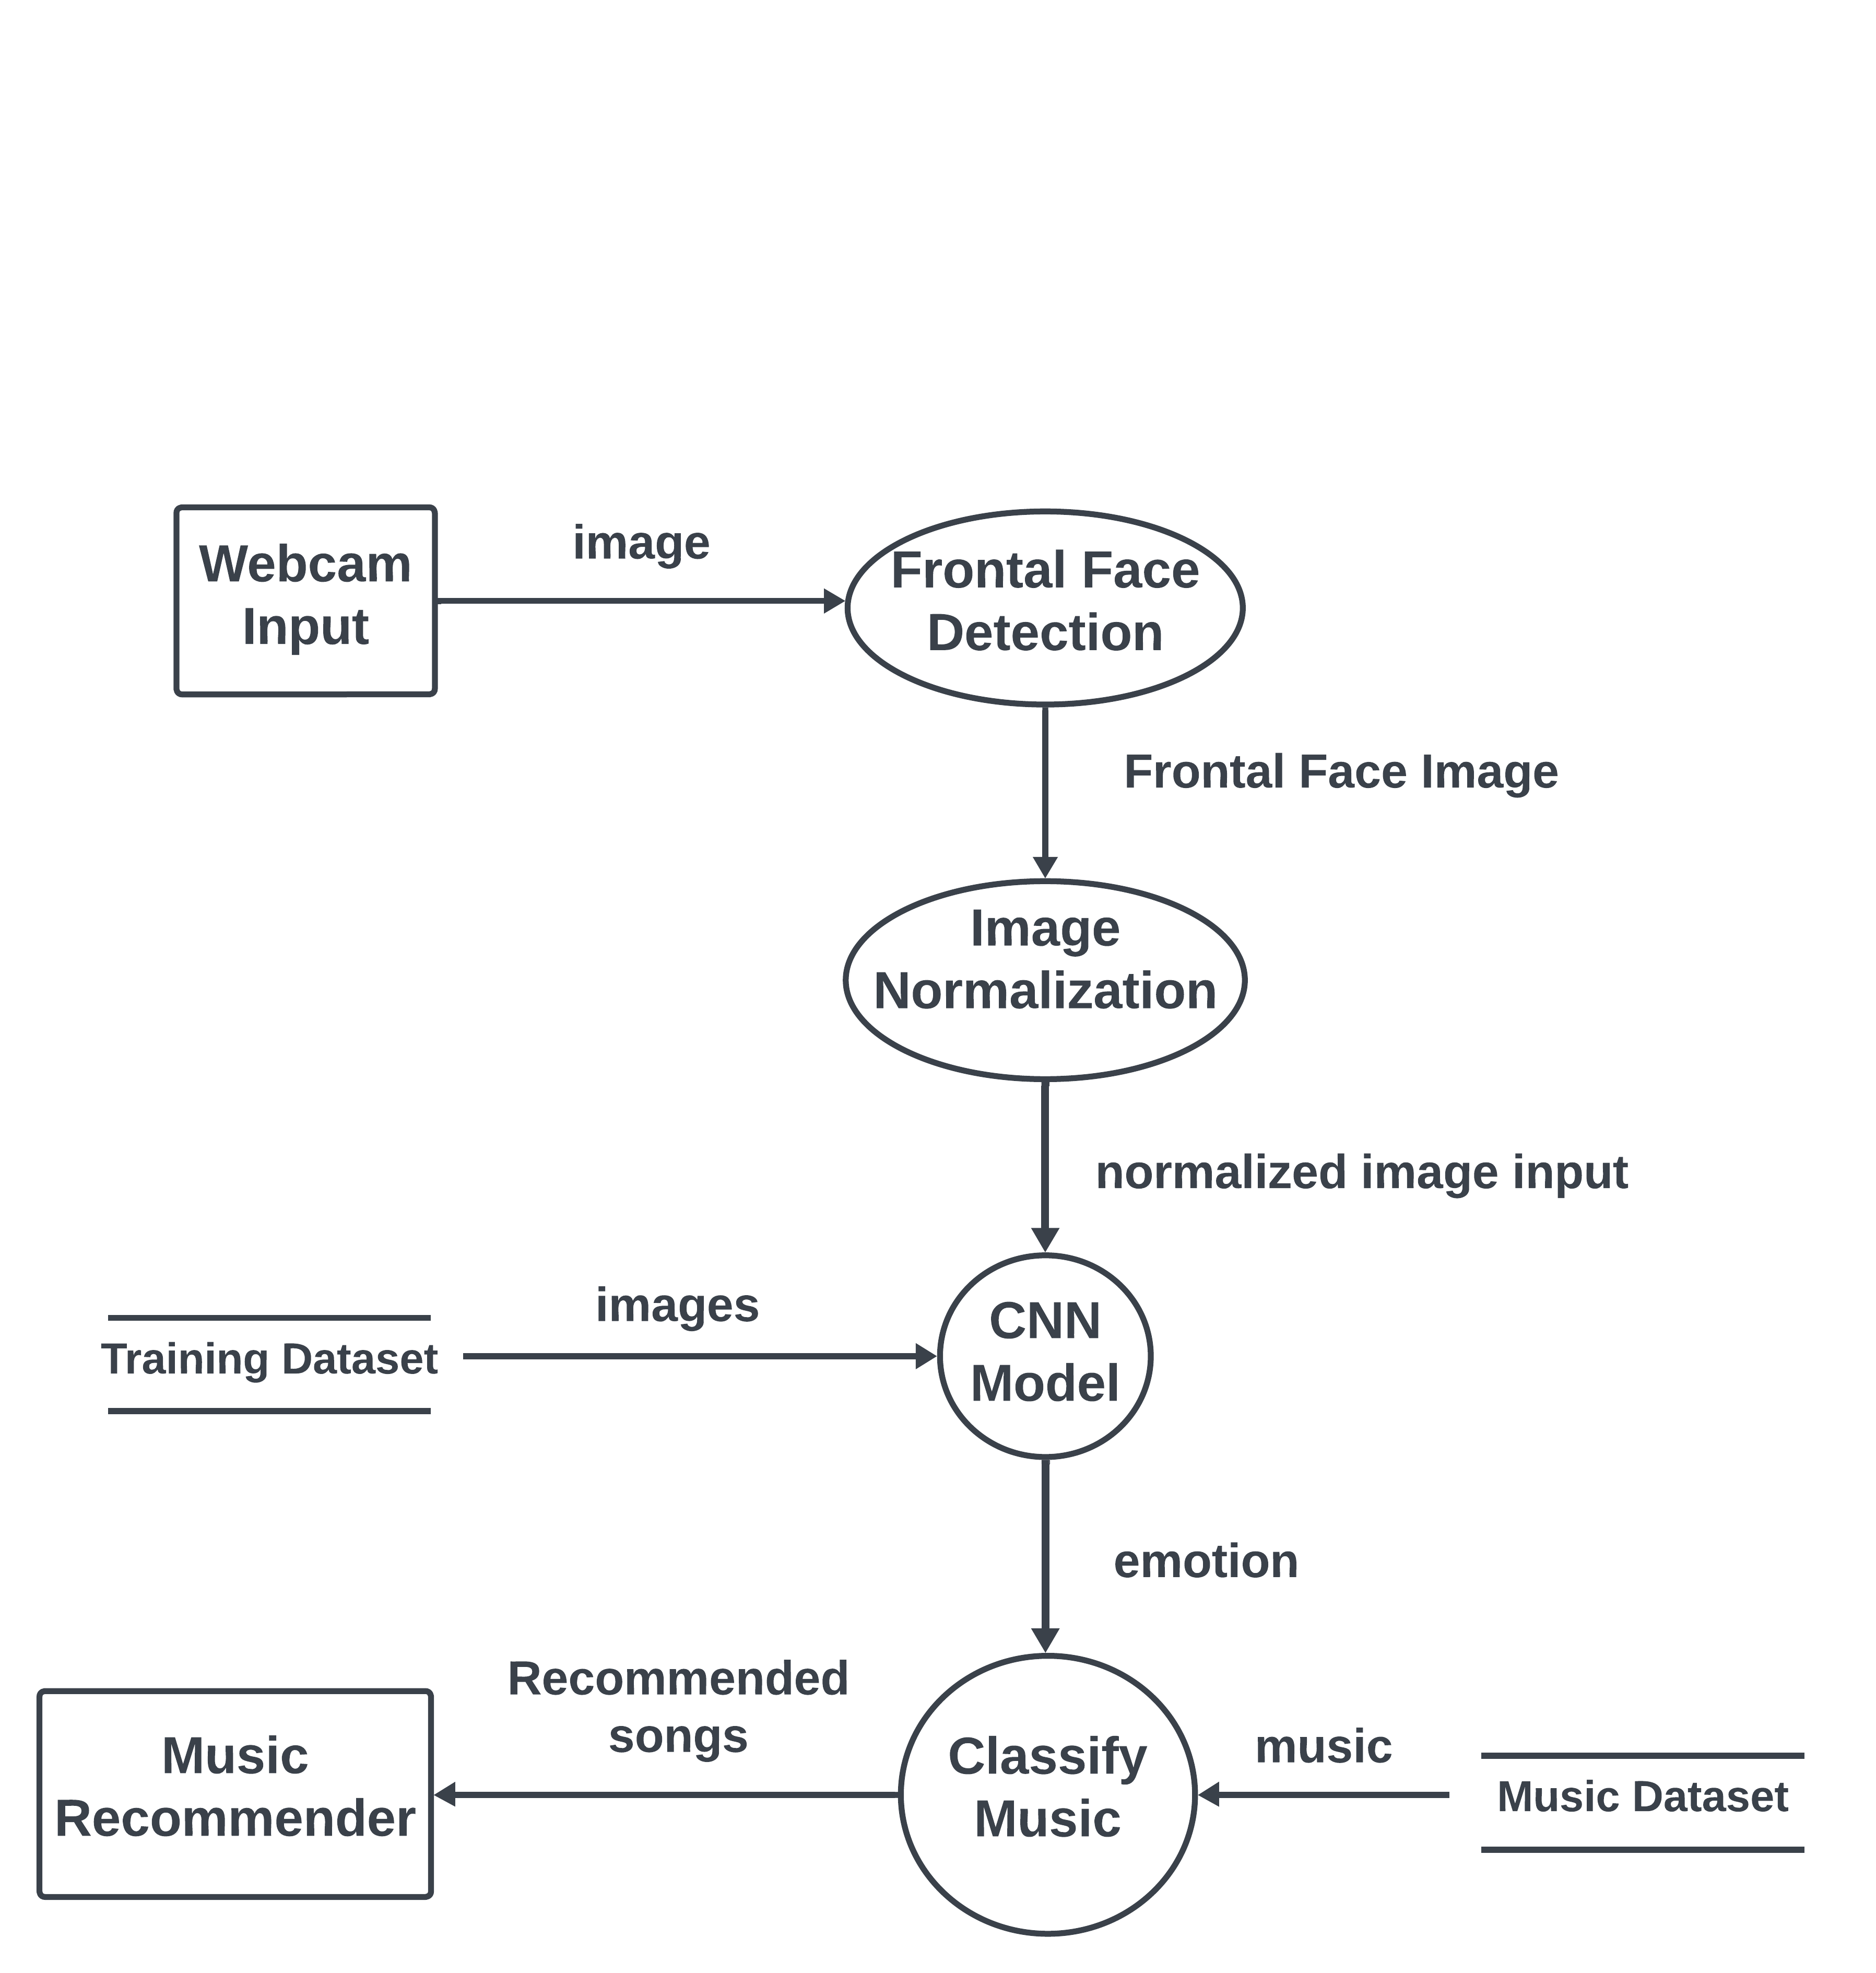

Figure 7: Level 1 DFD

## Sequence Diagram

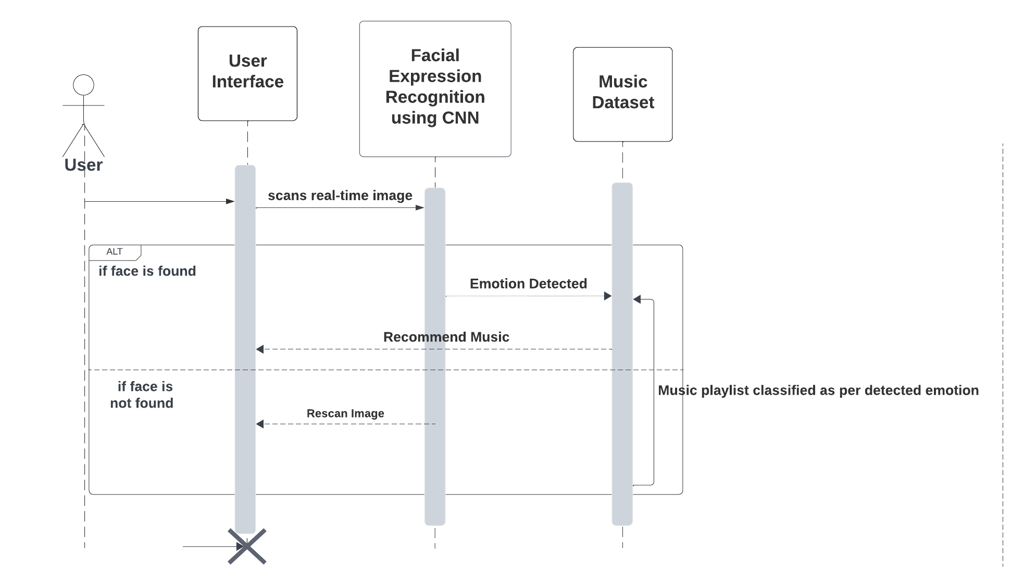

Figure 8: Sequence Diagram

# RESULTS AND DISCUSSION

The facial expression-based music recommendation system utilized Convolutional Neural Networks (CNN) for facial expression detection, complemented by the OpenCV2 Haar Cascade Classifier for frontal face identification, initially with a dataset of 35,887 images. The model underwent training and validation split of 90:10, with 32,298 images for training and 3,589 for validation and testing, addressing dataset imbalance with a RandomOverSampler. During training, achieving a training accuracy of 85.37% and a validation accuracy of 81.71% over 35 epochs and 64 batches with a learning rate set to 0.0001 and Adam optimizer, though it began overfitting thereafter. The training accuracy was found to be 81.71%. A Pygame-based Graphical User Interface (GUI) was integrated for emotion-based music recommendations, enhancing user experience. Enrichment of music recommendations was facilitated by a pre-classified music dataset, offering diverse options reflecting user preferences and emotional states. Top of Form

## 6.2 Perfomance Metrics Overview

The detailed classification report, as shown in figure, breaks down the model's performance across various emotion categories.

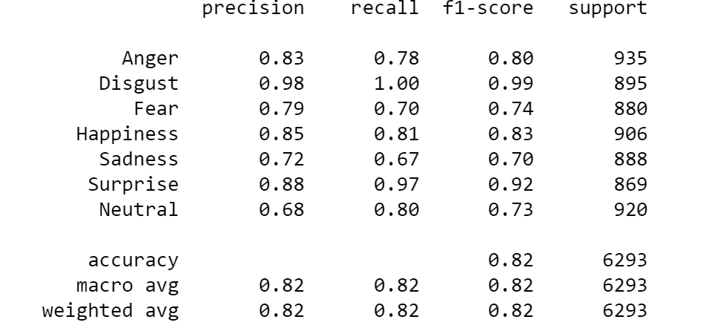

Figure 9: Classification Report

## 6.3 Visualization of Training vs Validation Accuracy

The graph illustrates the accuracy of a model changes as the number of training epochs increases over 35 epochs. The blue line represents the training accuracy and the orange line represents the validation accuracy. Both the training and validation accuracy increase as the number of epochs increases, but the validation accuracy plateaus after approximately 7-8 epochs.

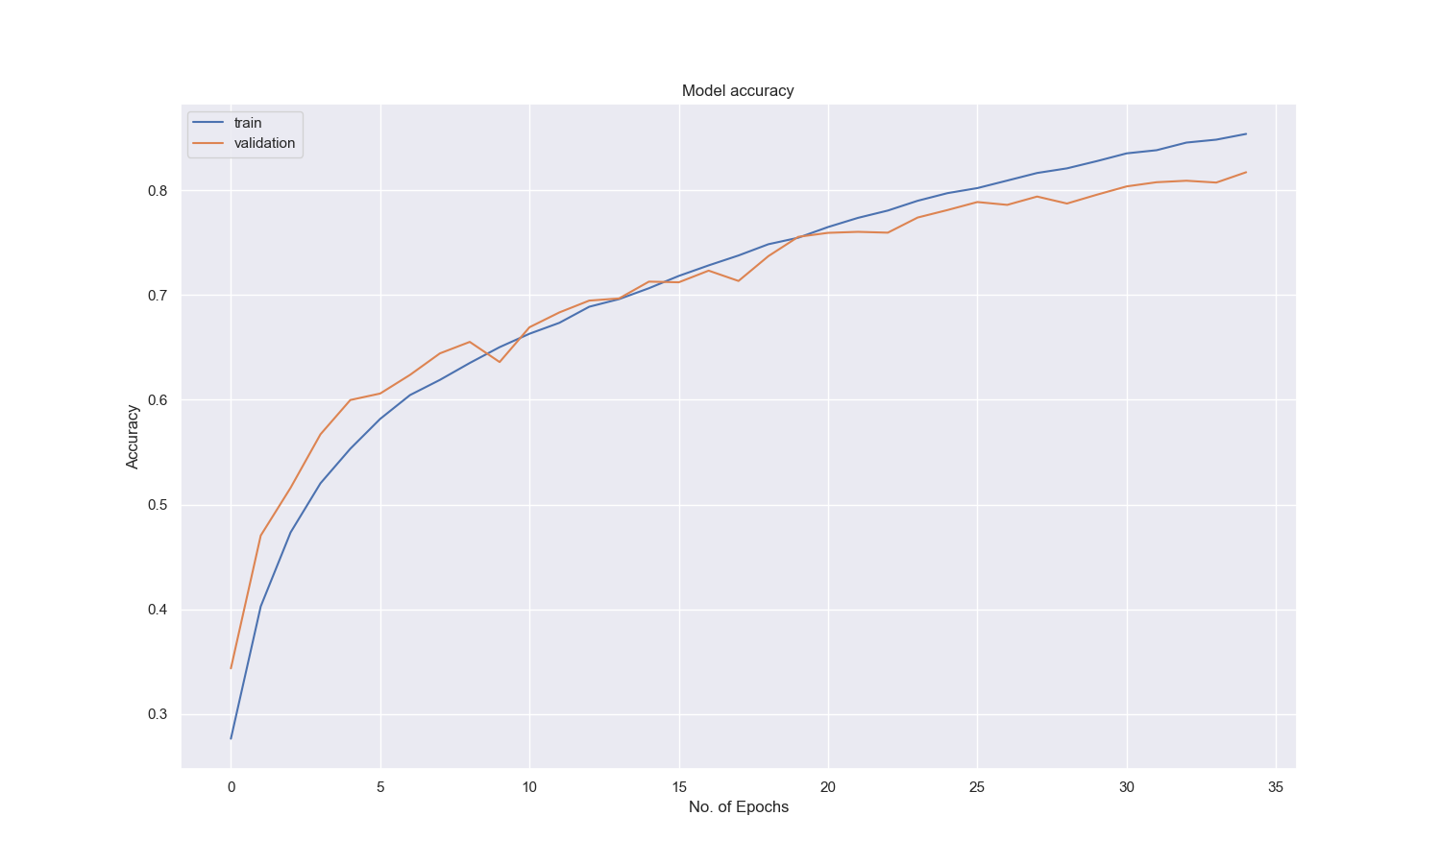

Figure 10: Training vs Validation Accuracy

## 6.3 Visualization of Training vs Validation Loss

The graph shows the training and validation loss of a model over 35 epochs. It appears that the training loss is decreasing over time, while the validation loss is fluctuating slightly.

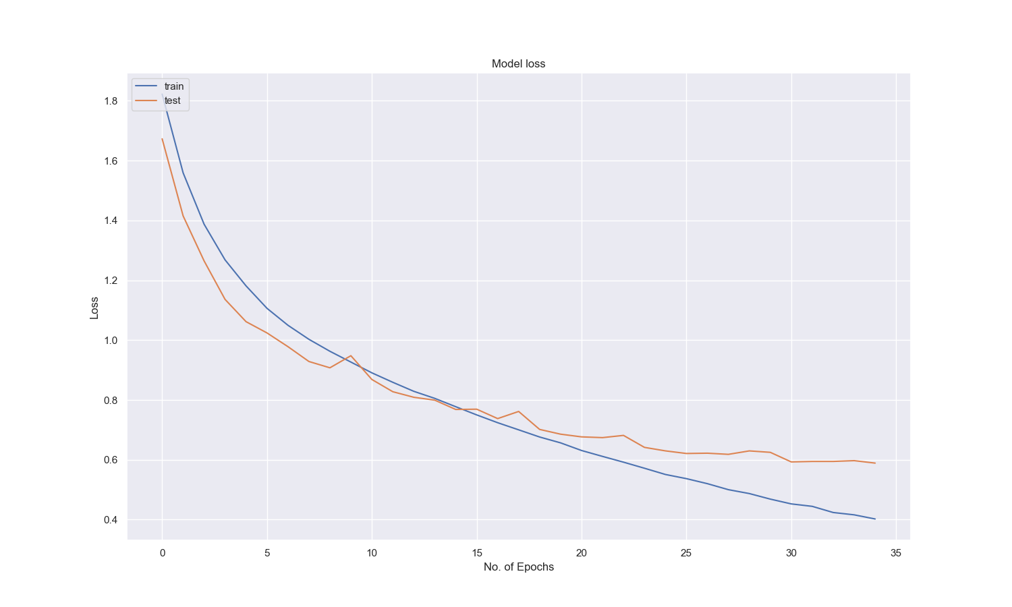

Figure 11: Training vs Validation Loss

## 6.4 Confusion Matrix

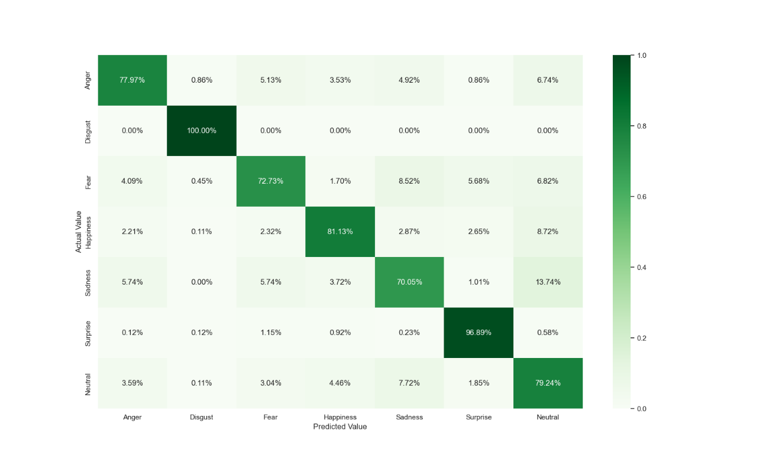  
The confusion matrix below provides a detailed breakdown of the model's predictions and actual labels, offering insights into misclassifications. Diagonal cells reflect accurate predictions: anger (100%), disgust (100%), sadness (81.13%), surprise (96.89%), and neutral (79.24%). Off-diagonal cells indicate misclassifications: happiness as sadness (5.74%), anger as fear (4.09%) etc.

Figure 12: Confusion Matrix

## 6.5 ROC-AUC Curve

The ROC-AUC curve visually represents the model's ability to distinguish between different emotions. Figure illustrates the ROC-AUC graph, demonstrating the trade-off between true positive rate and false positive rate. The model exhibits excellent performance in emotion classification, with all classes having high AUC values above 0.94, indicating strong discrimination capability, and particularly, classes Surprise and Disgust achieving perfect AUCs of 1.00.

Top of Form

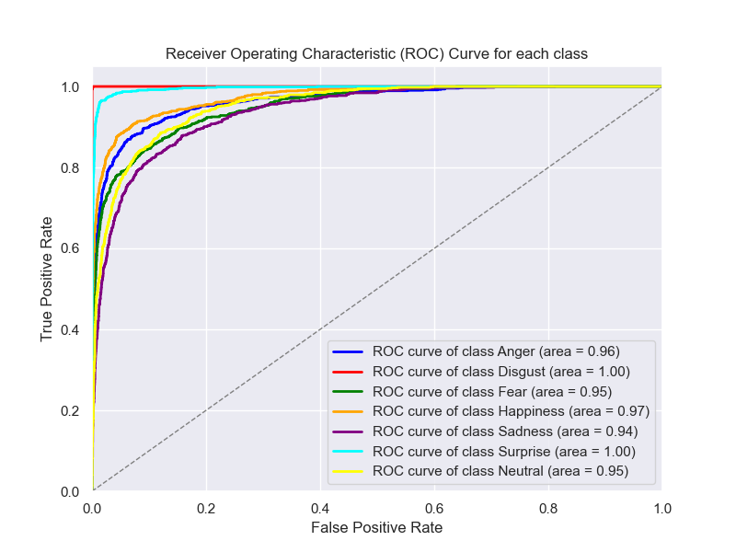

Figure 13: ROC-AUC Curve

# CONCLUSION

In conclusion, this project successfully implemented a facial expression-based music recommendation system using Convolutional Neural Networks (CNN) for facial expression detection and the OpenCV2 Haar Cascade Classifier for frontal face identification. The trained CNN model, leveraging the FER2013 dataset, demonstrated robust performance in accurately recognizing diverse emotional states, contributing to the system's real-world adaptability. The evaluation metrics, including accuracy, precision, recall, and F1-score, provided valuable insights into the reliability of the facial expression recognition model. The integration of a Pygame-based graphical user interface (GUI) enhanced user interaction, allowing seamless emotion-based music recommendations.

The music recommendation system, relying on a pre-classified music dataset, enriched recommendation relevance. An analysis of the dataset's diversity, size, and genre distribution revealed insights into the system's versatility. Notably, handling class imbalance through random oversampling significantly improved the model's performance, ensuring a more balanced representation of emotions.

In summary, this project achieved its objectives by creating an effective facial expression-based music recommendation system. The results and achievements highlight the successful integration of machine learning and computer vision techniques to enhance user experience in music recommendation.

# LIMITATIONS AND FUTURE WORK

## Limitations

* **Limited Emotion Classes:**

The FER2013 dataset may have limitations in terms of the variety and granularity of emotion classes. The model's ability to accurately detect and differentiate between subtle emotions may be constrained by the dataset.

* **Environmental Factors:**

The system's performance may be affected by variations in lighting, background, and other environmental factors. Different lighting conditions and backgrounds can impact the accuracy of facial expression detection.

* **Imperfect Correlation Between Facial Expression and Emotion:**

Facial expressions might not always accurately represent an individual's emotional state. People can exhibit similar facial expressions for different emotions, and cultural or individual variations may further complicate the correlation between facial expressions and emotions. The system's reliance solely on facial cues may lead to misinterpretations of the user's true emotional state.

* **Limited Music Dataset:**

The system's music recommendation is dependent on a pre-classified music dataset. The size and diversity of this dataset may affect the variety and relevance of recommended music.

## Future Works

* **Dynamic Music-Emotion Mapping:**

Develop a more sophisticated and adaptable mapping system that takes into account factors like user preferences, context (e.g., activity, time of day), and musical characteristics beyond just genre. Allow users to provide feedback and personalize the mapping based on their individual preferences.

* **Improved Emotion Recognition Models:**

Explore and implement more advanced and state-of-the-art models for emotion recognition. This could involve using larger and more diverse datasets, or even considering multimodal approaches that incorporate additional features like voice analysis.

* **User Interface Enhancement:**

Improve the graphical user interface (GUI) for a more intuitive and engaging user experience. Consider incorporating features such as playlist customization, visualization of emotional trends, or social sharing.

# REFERENCES

|  |  |
| --- | --- |
| [1] | T. Schäfer, P. Sedlmeier, C. Städtler, D. Huron, "The psychological functions of music listening," *Frontiers in psychology,* vol. 4, p. 3, 2013. |
| [2] | M. Liu, Y. Duan, R. A. A. Ince, C. Chen, O. G. B. Garrod, P. G. Schyns, and R. E. Jack, "Facial expressions elicit multiplexed perceptions of emotion categories and dimensions," *Current Biology,* vol. 32, no. 1, p. 203, 2022. |
| [3] | D. L. Bin Li, "Facial expression recognition via ResNet-50," *International Journal of Cognitive Computing in Engineering,* vol. 2, pp. 57-64, 2021. |
| [4] | A. G. P. R. CH.sadhvika, "Emotion Based Music Recommendation System," *International Journal of Emerging Technologies and Innovative Research ,* vol. 7, no. 4, pp. 2170-2175, 2020. |
| [5] | D. M. U. S. M. G. Madhuri Athavle, "Music Recommendation Based on Face Emotion Recognition," *Journal of Informatics Electrical and Electronics Engineering (JIEEE),* vol. 2, no. 2, pp. 1-11, 2021. |
| [6] | G. H. Ahmed Hamdy AlDeeb, "Emotion-Based Music Player Emotion Detection from Live Camera," Research Gate, 2019. |
| [7] | S. M. ,. J. P. ,. V. B. J. V. K. Ankita Mahadik, *INTERNATIONAL JOURNAL OF ENGINEERING RESEARCH & TECHNOLOGY,* vol. 10, no. 6, 2021. |
| [8] | A. R. Lovelit Jose, "Advanced Music Application with Music Recommendation system based on Facial Expression Using Machine Learning," *International Journal of Innovative Research in Science, Engineering and Technology,* vol. 12, no. 2, pp. 478-482, 2023. |

# APPENDICES

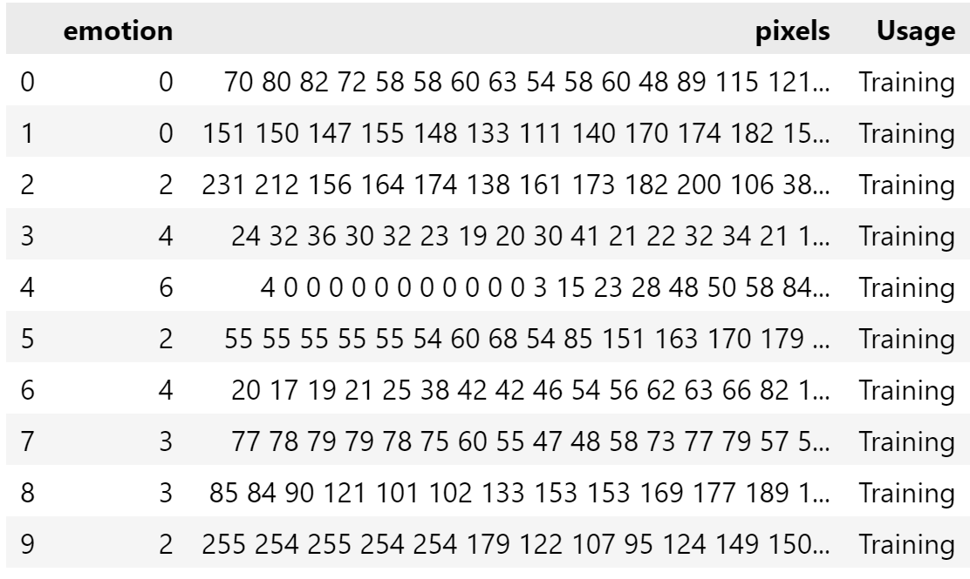

Figure 14: FER2013 Dataset

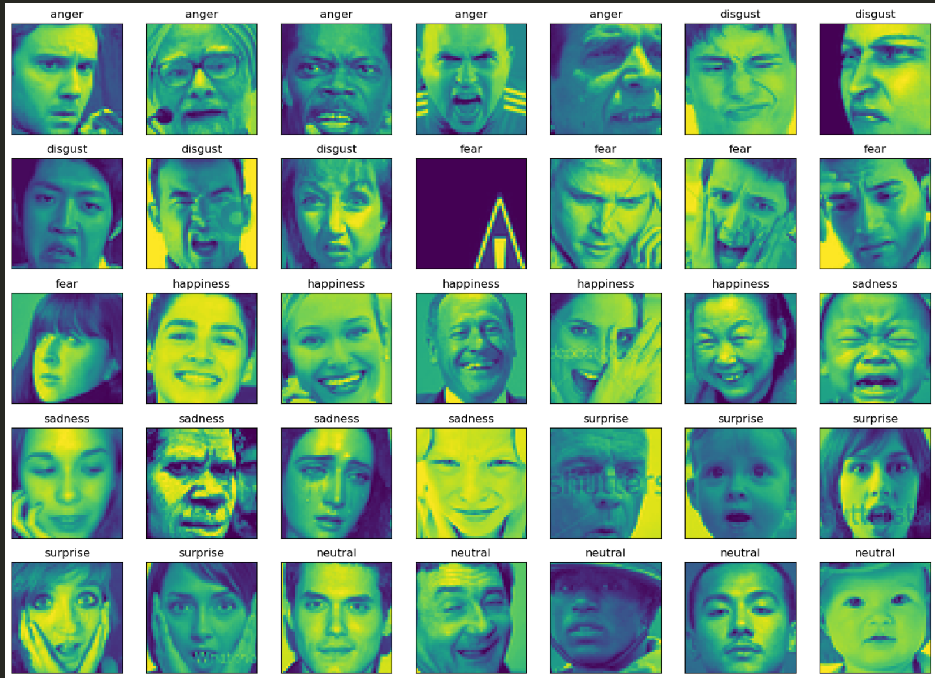

Figure 15: Sample Images from FER2013 Dataset

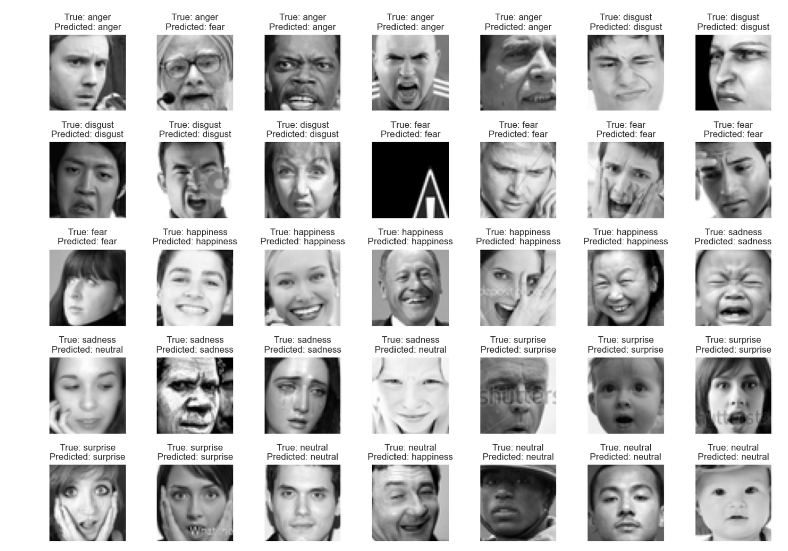

Figure 16: Emotion Classification: True vs Predicted Values

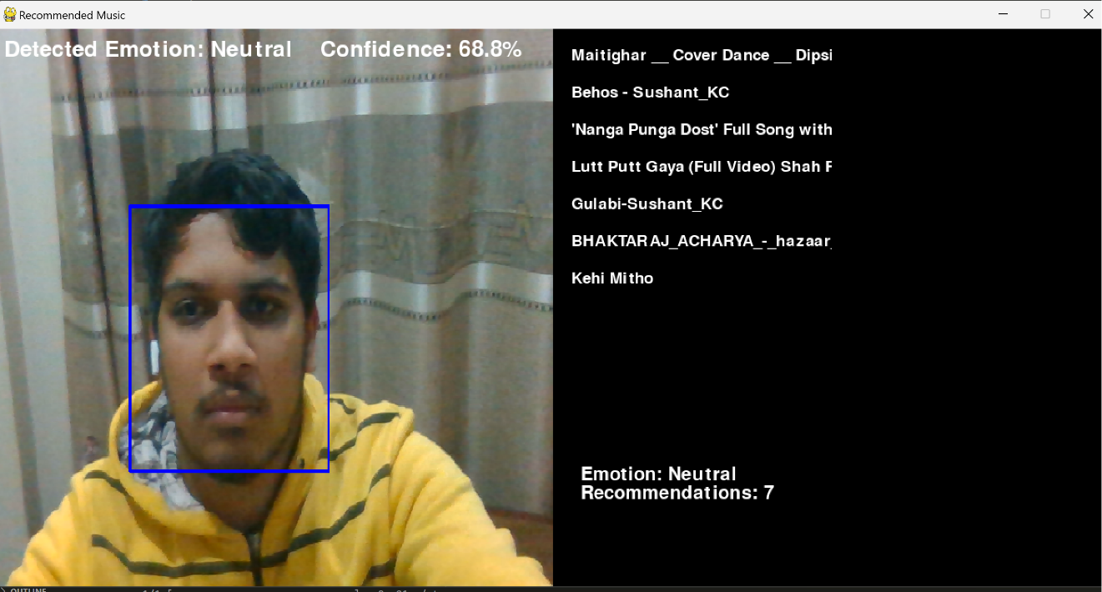

Figure 17: Neutral emotion detected in GUI